Name Roll#

*Altamash Yar Khan (TL) 17L4402*

*Farooq Ahmed 17L4407*

*Nayab Ahmad 17L4498*

Airline Management System

*Detailed Design Document*

Final Version

SUBMISSION DATE:15/06/2021

TO: Sir Waheed Faraz

Revision History

| Date | Version | Description | Author |
| --- | --- | --- | --- |
| 14/06/2021 | 3.0 | Few changes were made in the ER diagram and wrote SQL queries. | Altamash Yar Khan |
| 14/06/2021 | 3.0 | HTML pages were modified using css and javascript with the help of bootstrap. ---- was used to connect database with the html webpage. | Farooq Ahmad & Nayab Ahmad |
|  |  |  |  |

Definitions of Terms, Acronyms and Abbreviations

| Term | Description |
| --- | --- |
| ER Model | Entity-Relationship Model |
| DD | Data Dictionary |
| EER | Enhanced Entity-Relationship Model |
| RS | Relational Schema |

Table of Contents

1. Introduction 4

2. Assumptions 4

3. ER Diagram 4

4. Relational Design 4

5. Data Dictionary(optional) 4

6. Prototype using GUIs 4

7. References 4

# Introduction (SLO 5.1)

The Purpose of this report is to give an overview of how we managed to design and develop our Airline Management System Project. Initially, we started off with designing the EER diagram. Changes in the EER diagram were made regularly with time with respect to the problem statement to make our project more efficient. After Finalizing the EER diagram we proceeded with making the Relational schema through the ERWin software and by manually creating the table in word file. After designing the Relational schema we got a better picture of how our project would be constructed further. We created tables of our Entity in My SQL using basic create update alter queries. Finally we were able to design the HTML webpage using css styling and java script and further linking the front end of our website to the backend where the data is transferred to the SQL through php script using xampp.

# Assumptions (SLO 5.2)

* *One passenger can only book once for a flight*
* *Each Flight can select one type of meal*
* *After booking, a passenger can then choose the Class type in the flight i.e. Business or Economy.*
* *Class Type seats are not reliant on type of Aircraft.*
* *City Name attribute basically refers to both, the source and destination city.*
* *Flight Entity has all the information about the flight, travelling, pilot etc from which the administrator can view the details.*

## *One flight can be handled by many administrators.*

## *Pilots can fly specific type of plane of an aircraft.*

## *Each Flight can travel to one city at a time.*

## *Passenger No(P.NO) is the unique key of PASSENGER entity*

## *Registration no of USERS entity is the primary key*

## *ID is the unique key of ADMINISTRATION entity*

## *Flight_No is the primary key of FLIGHTS entity.*

## *CITY entity Name as the primary key.*

## *Users can Book Flights once they’ve become passengers successfully.*

# Revised ER Diagram (SLO 5.2+5.3+5.4)

## 

# Relational Design (SLO 5.2+5.3+5.4)

# Erwin Software.

# Table Form:

# 

# Data Dictionary (SLO 5.3)

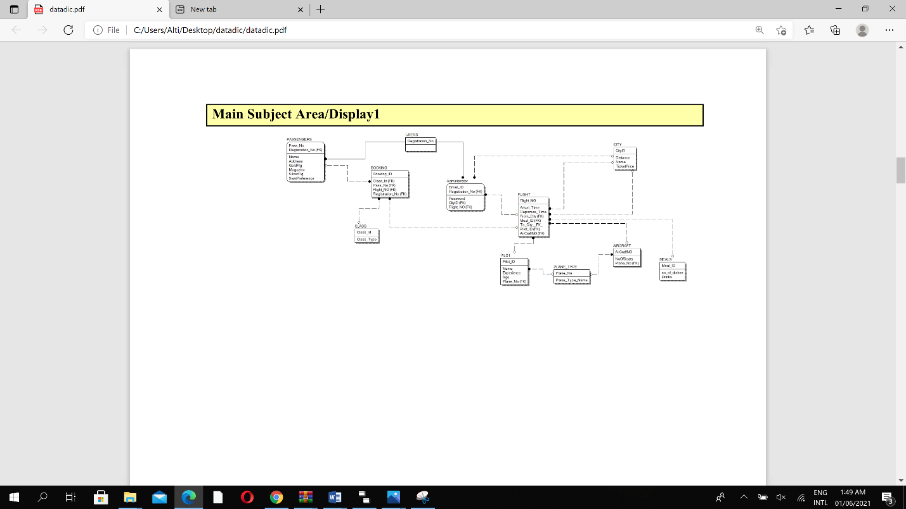

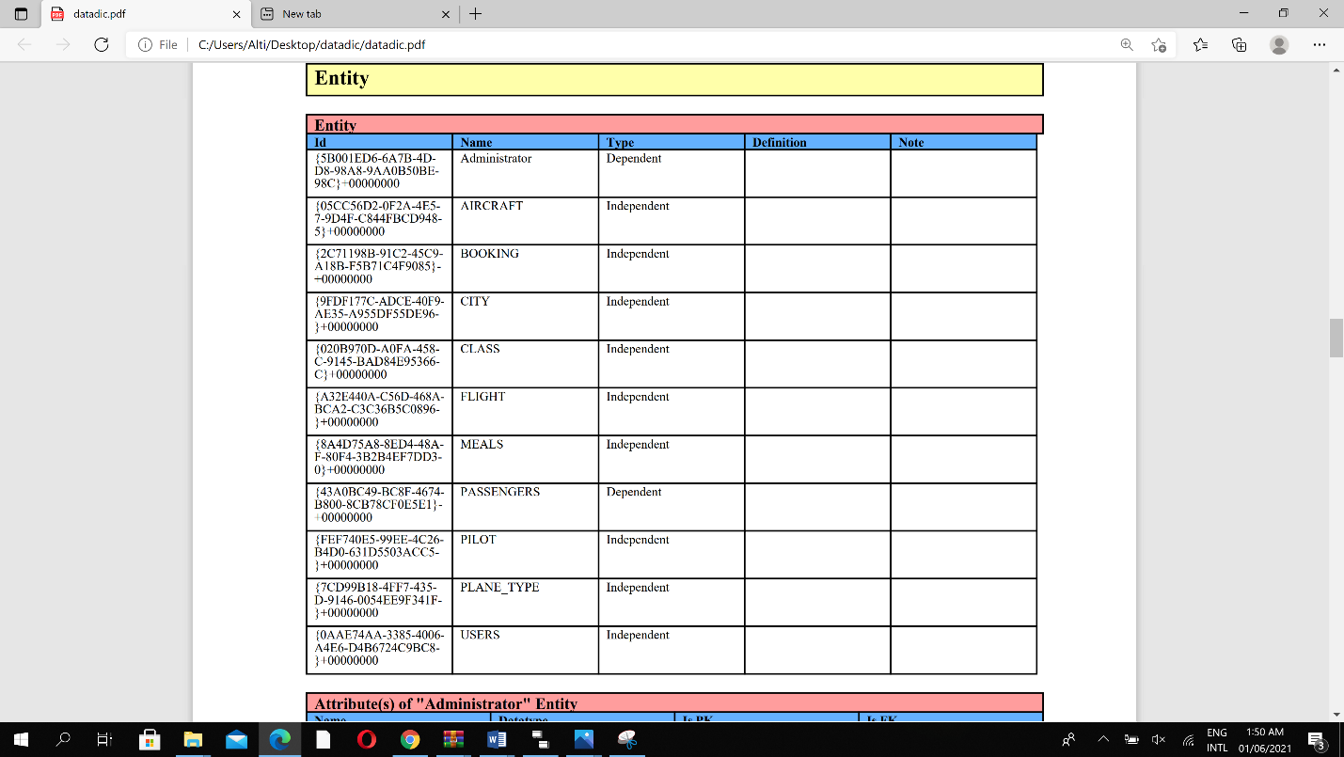

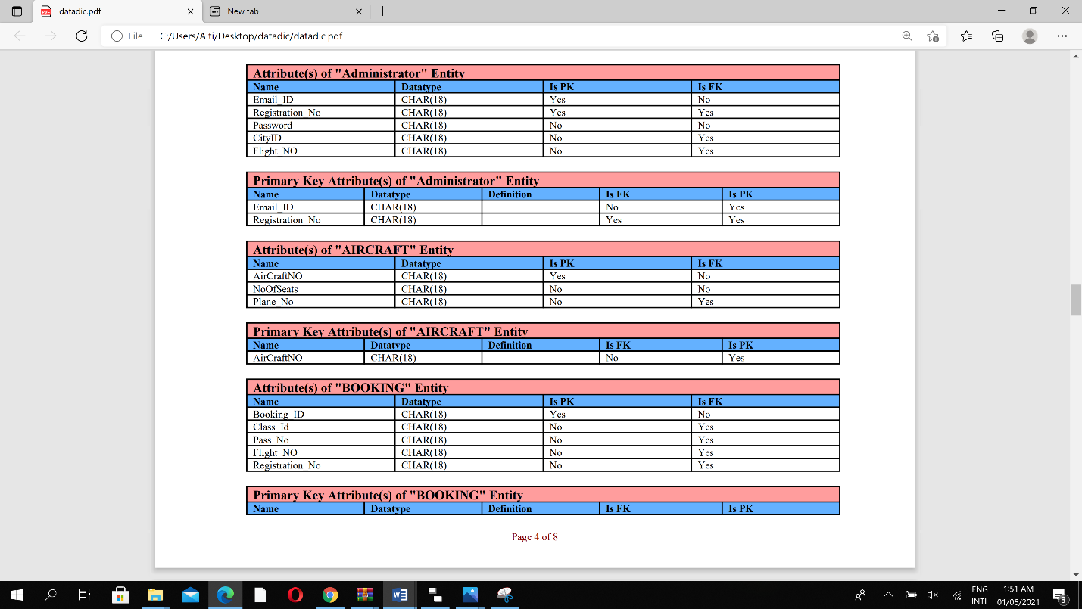

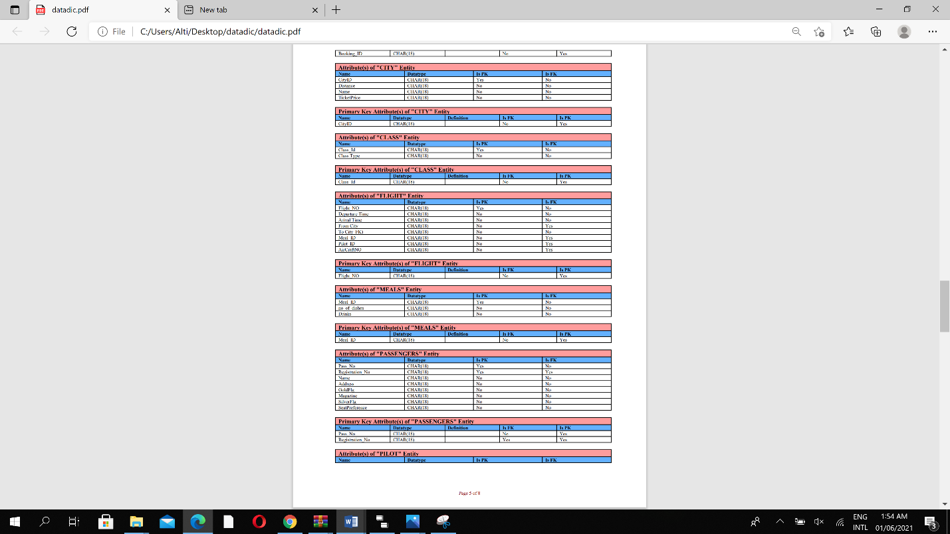

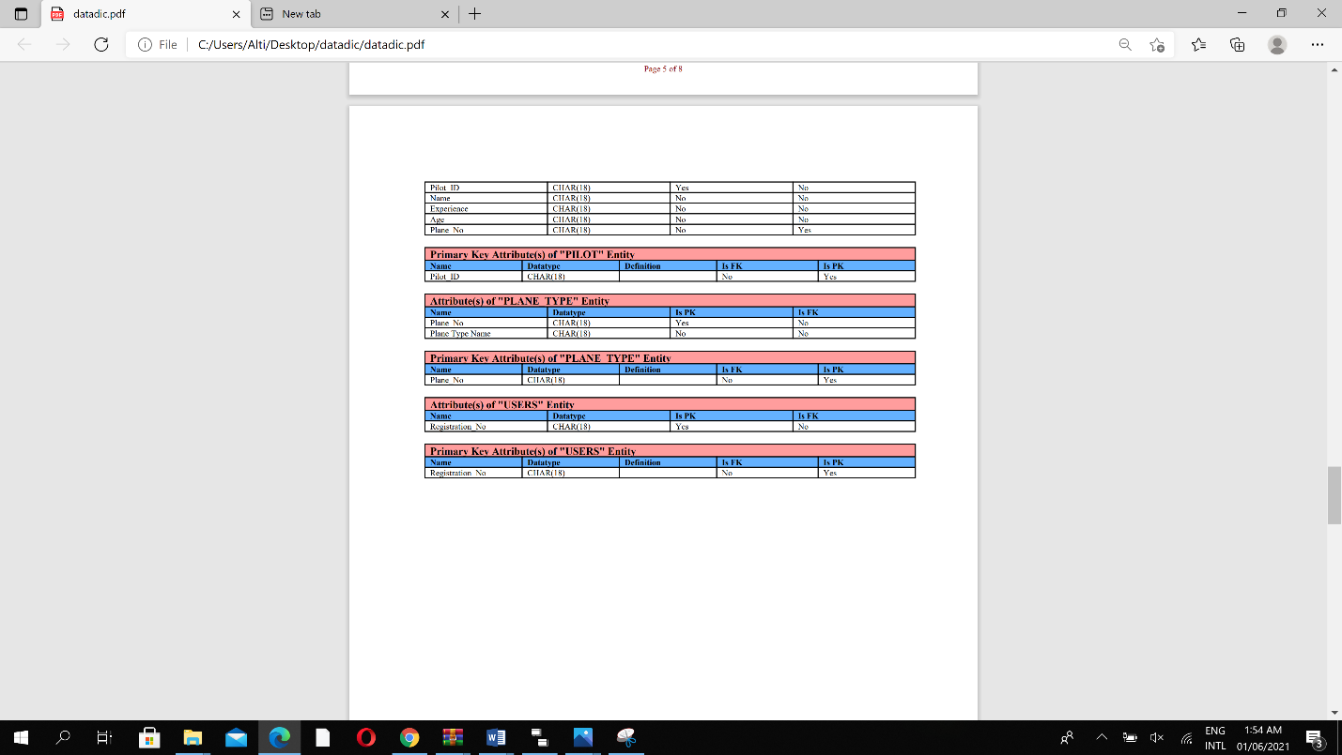

# Prototype using GUIs (SLO 5.2 +5.3 + 5.4)

# HTML WEB PAGE using CSS and JAVASCRIPT

Home Page:

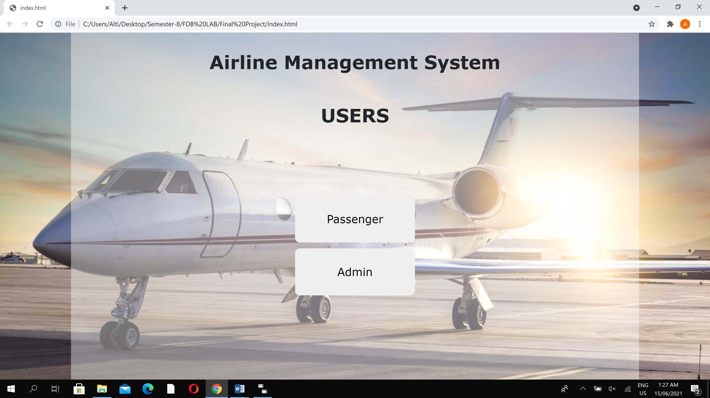

User: Passenger

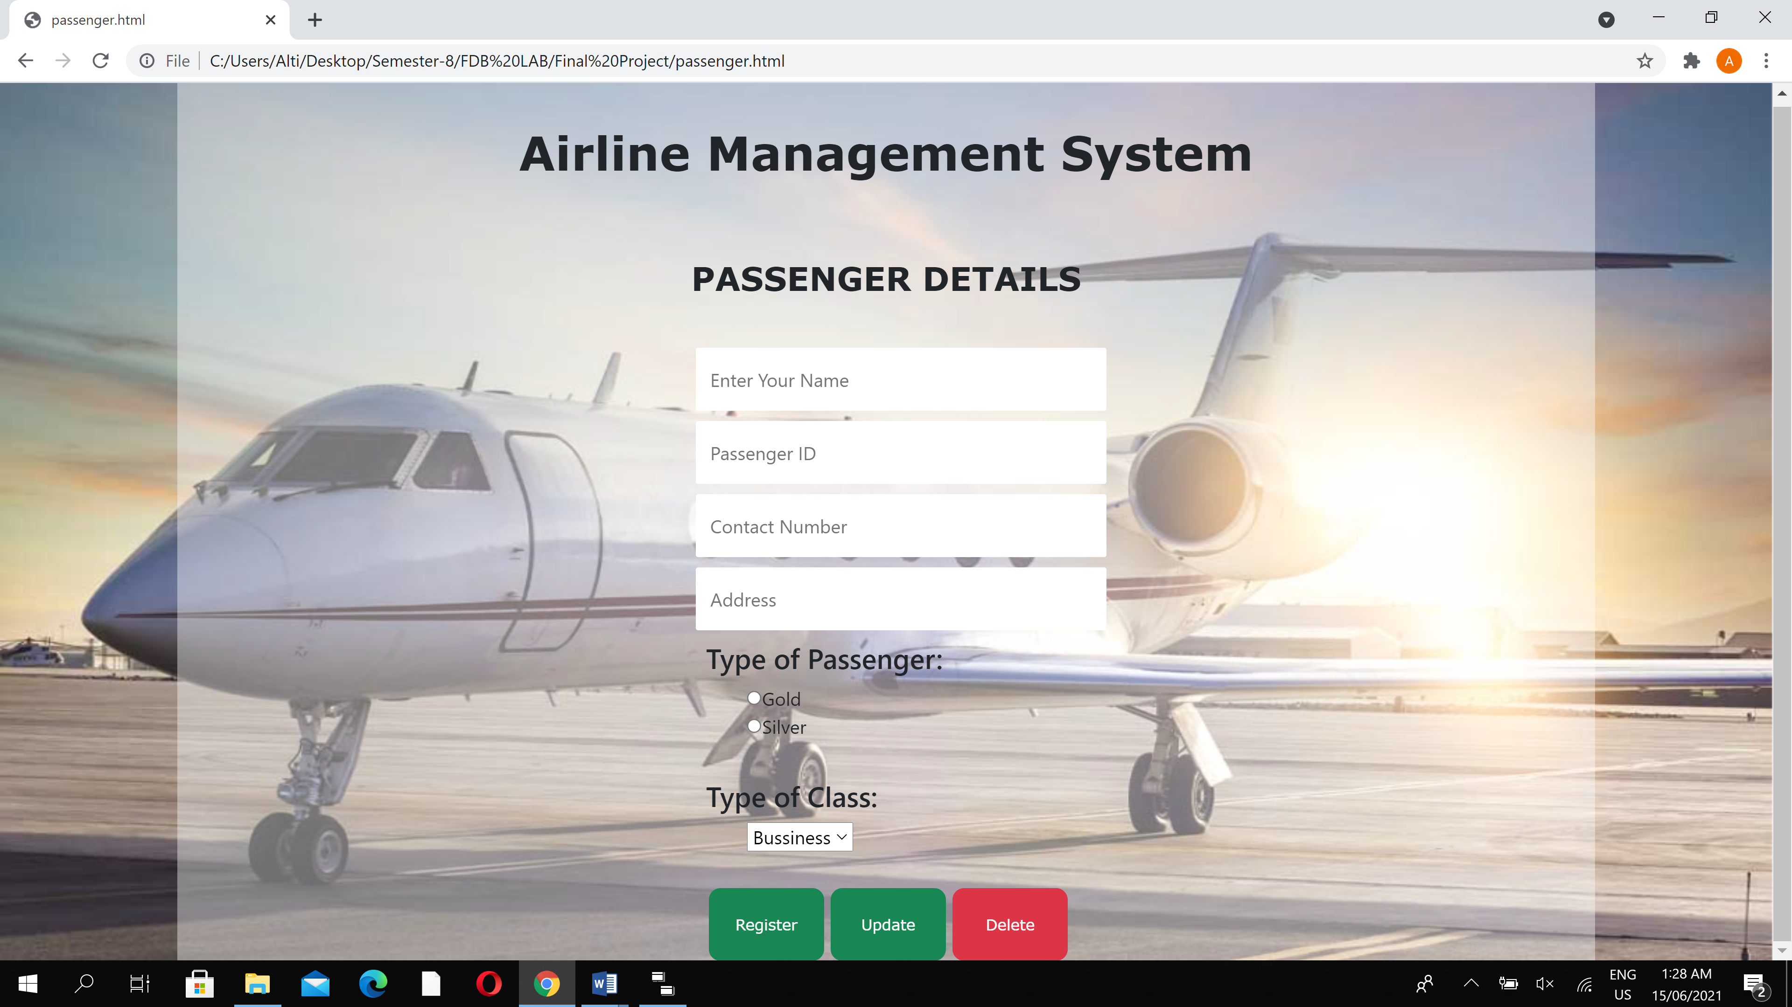

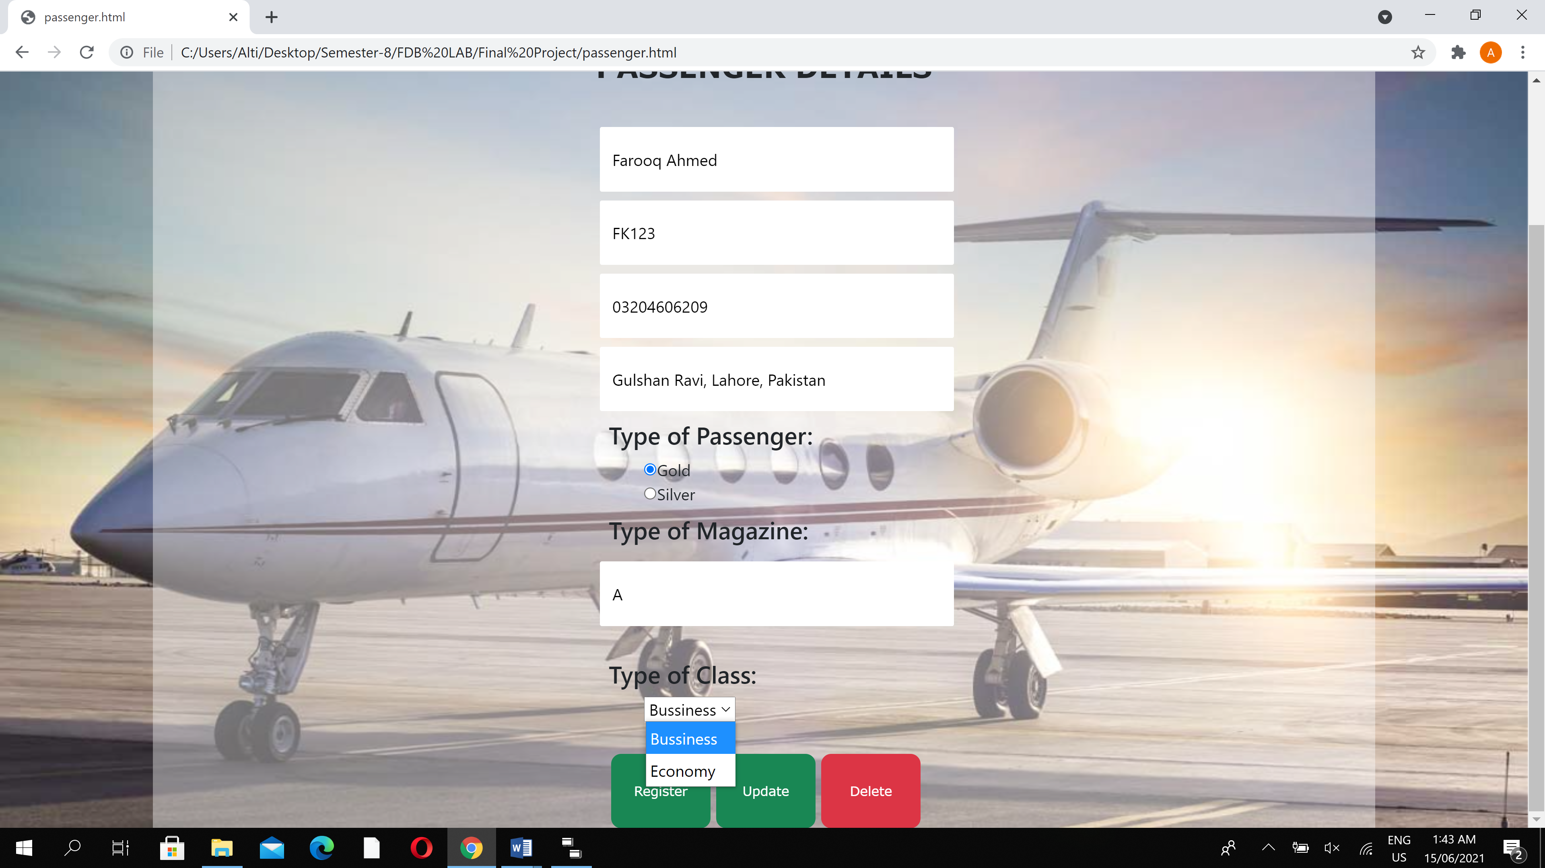

User: Administrator :

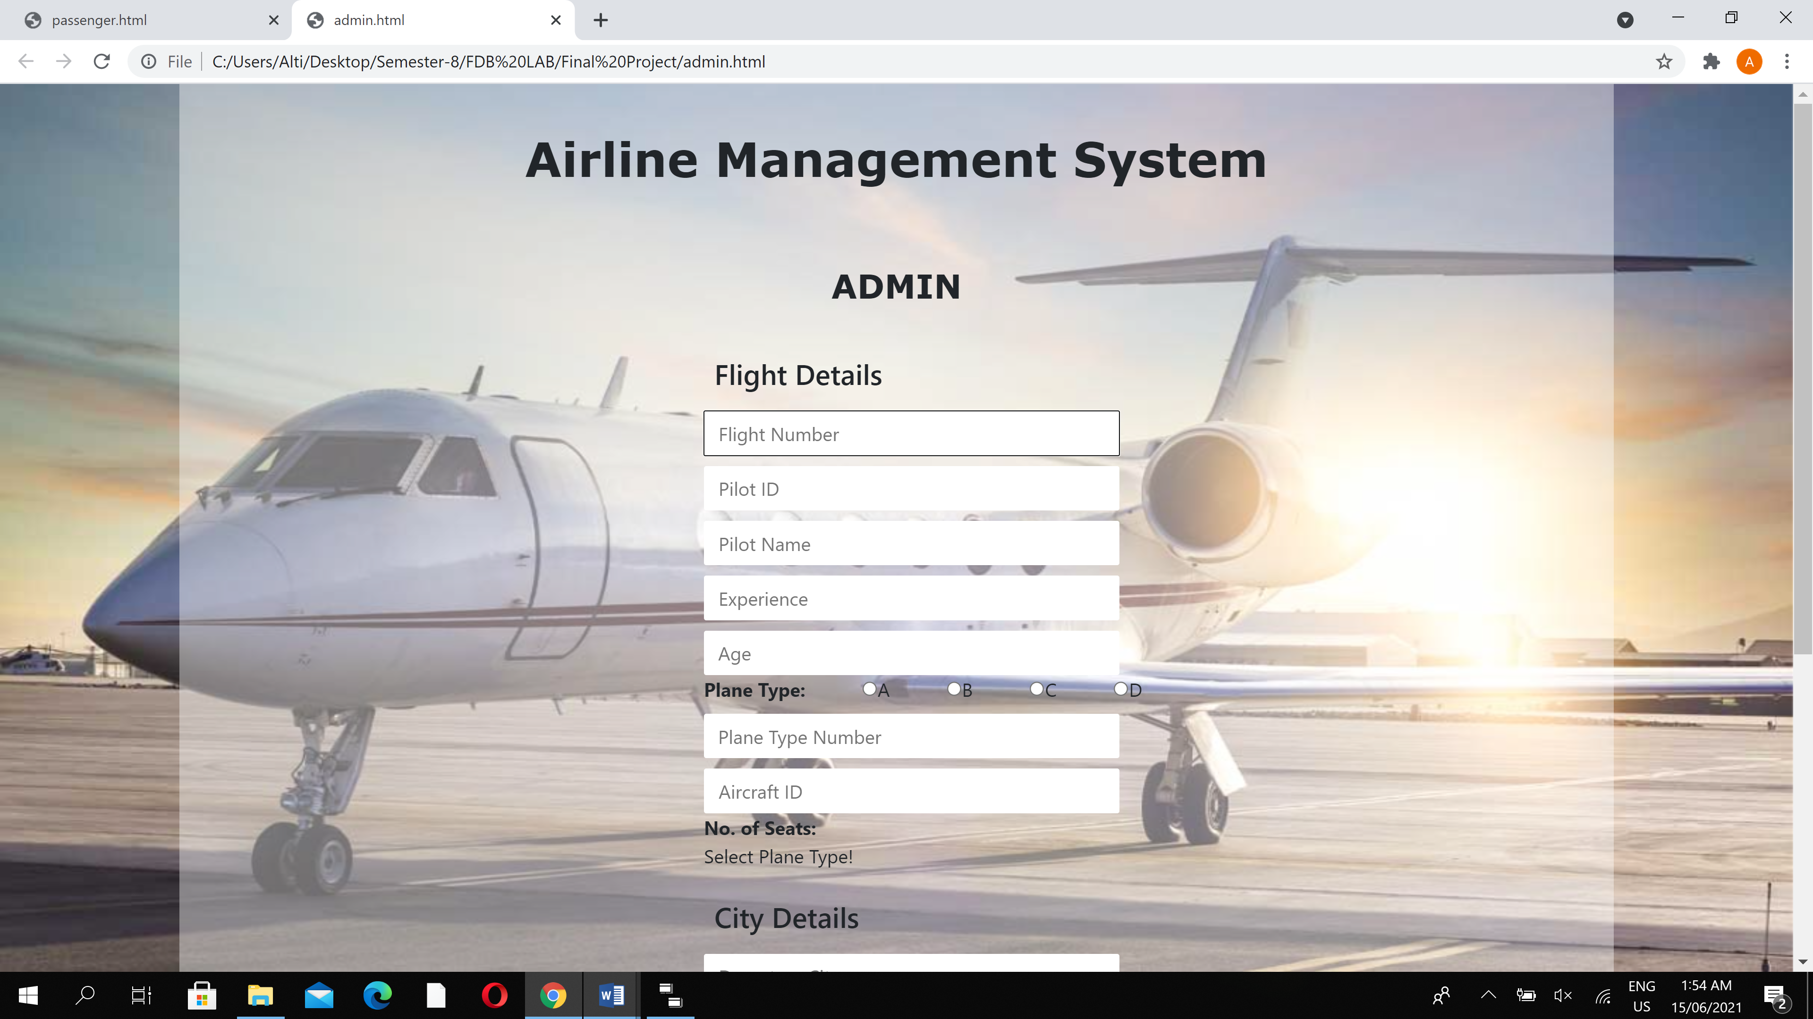

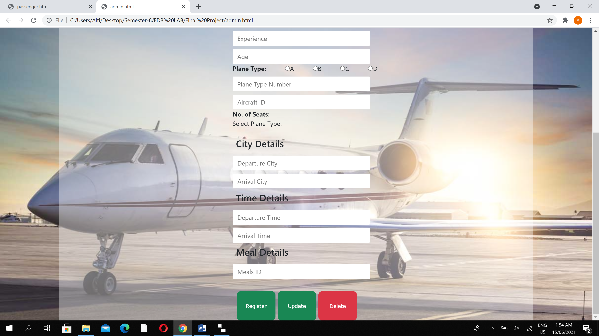

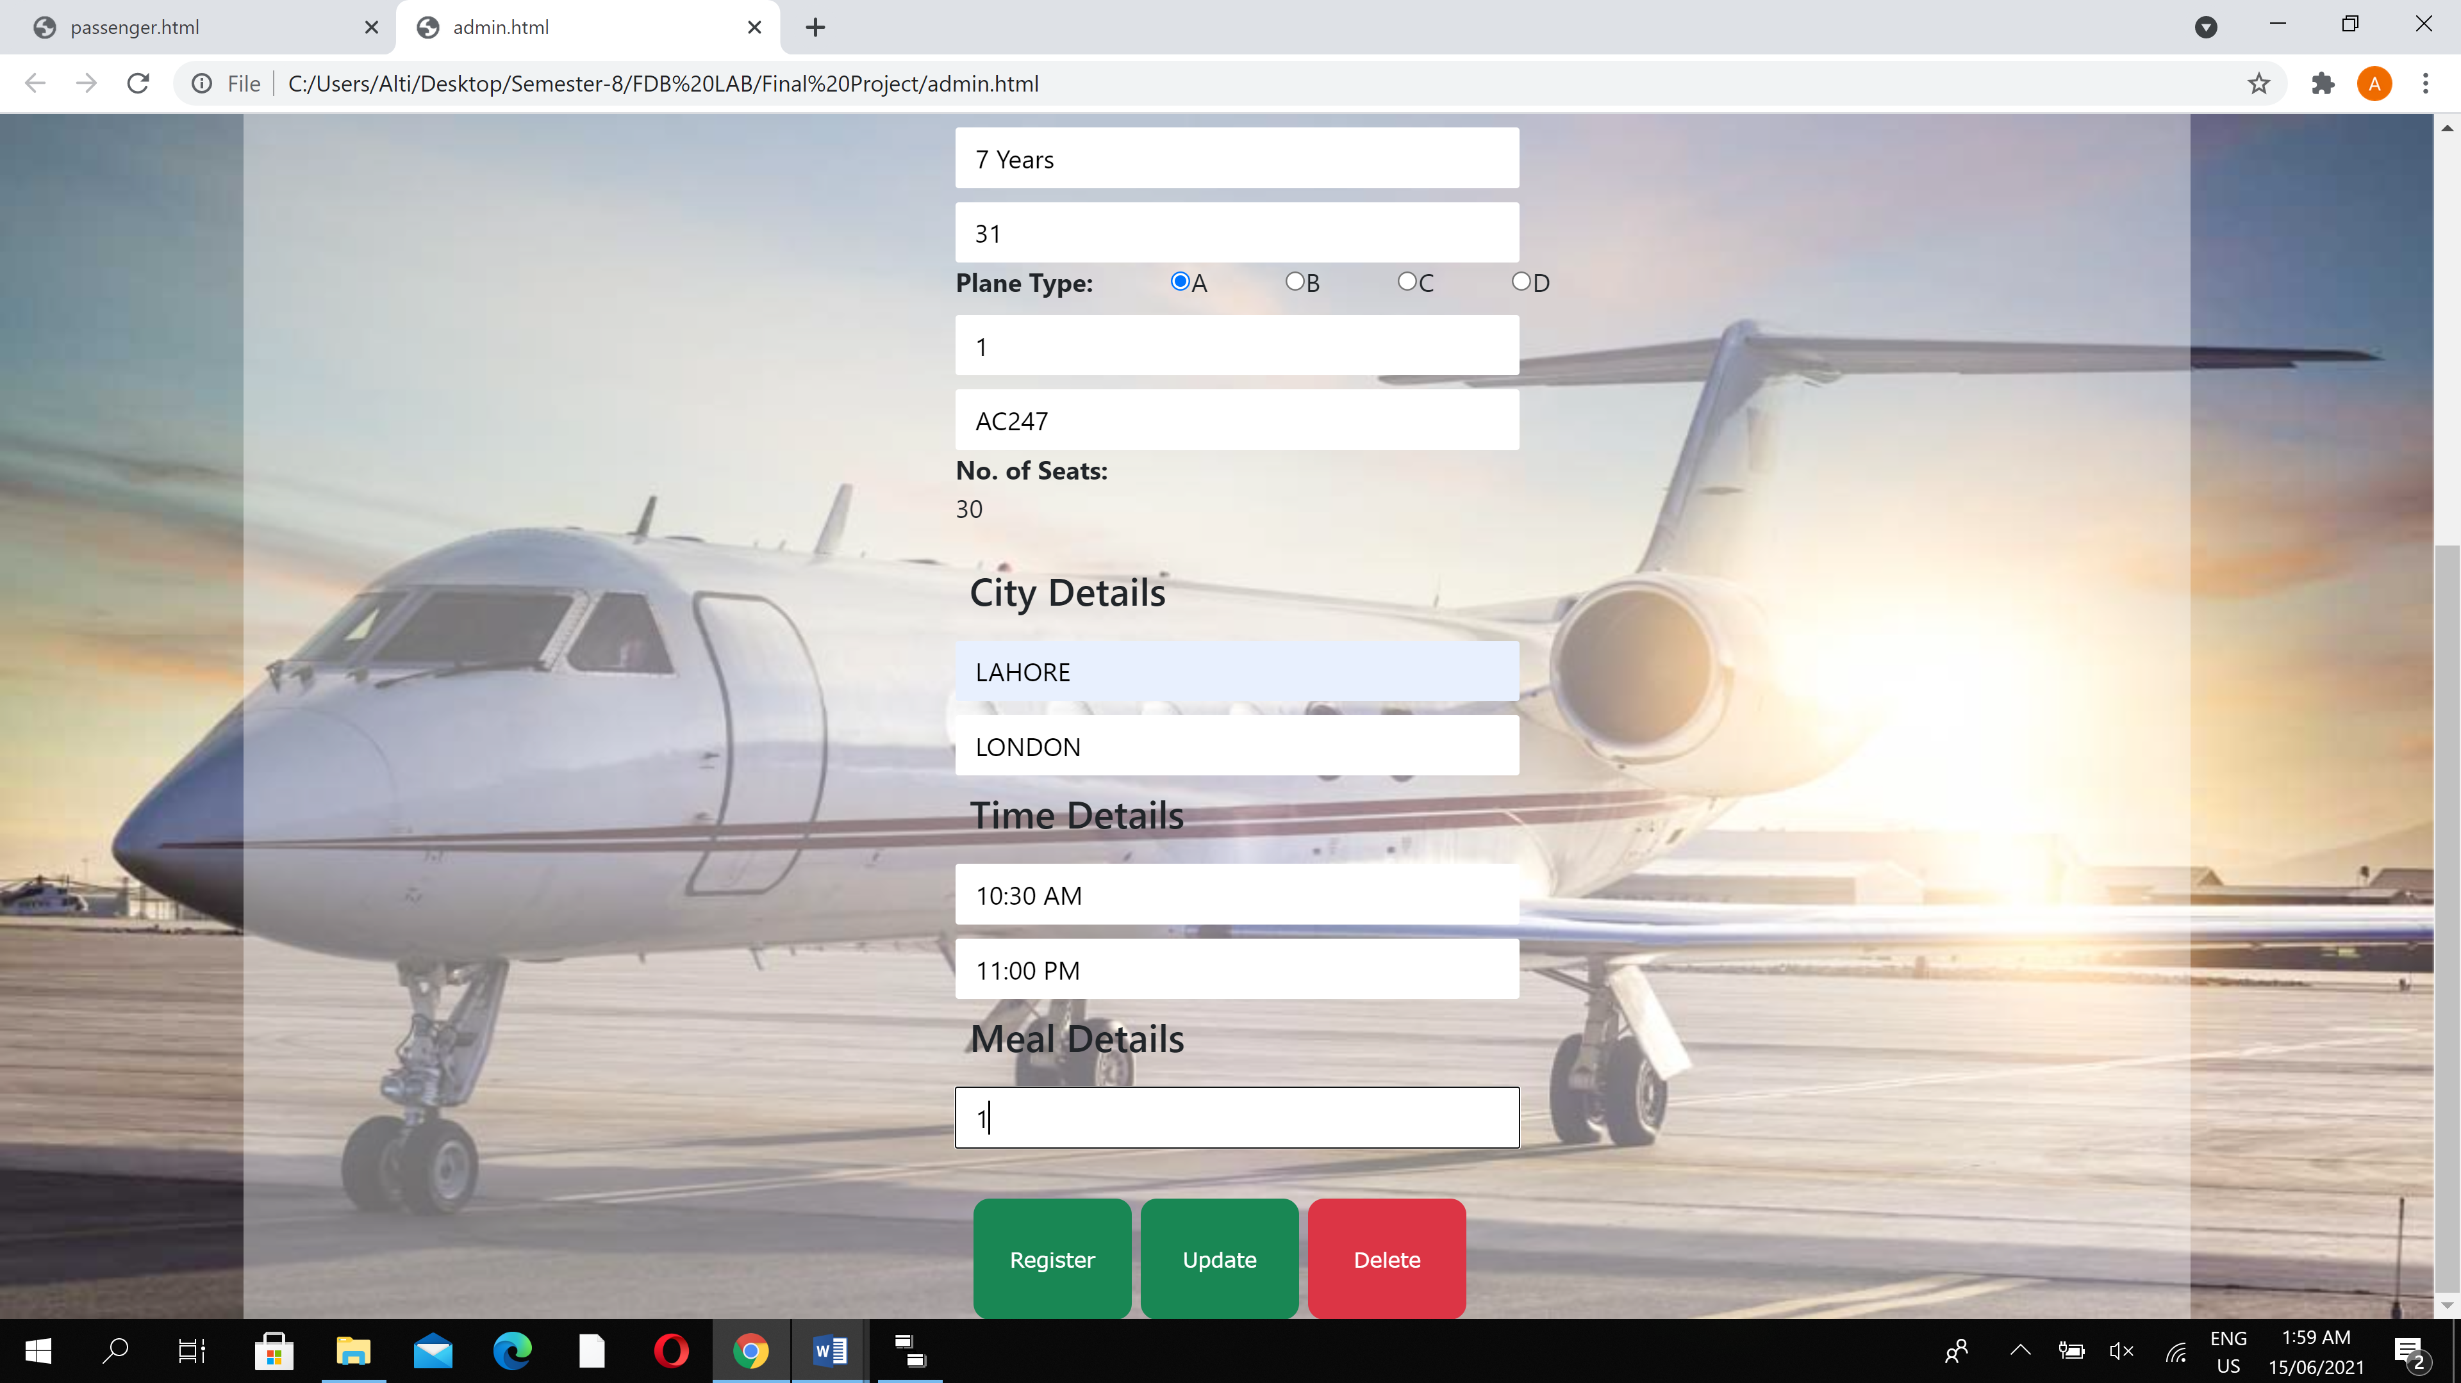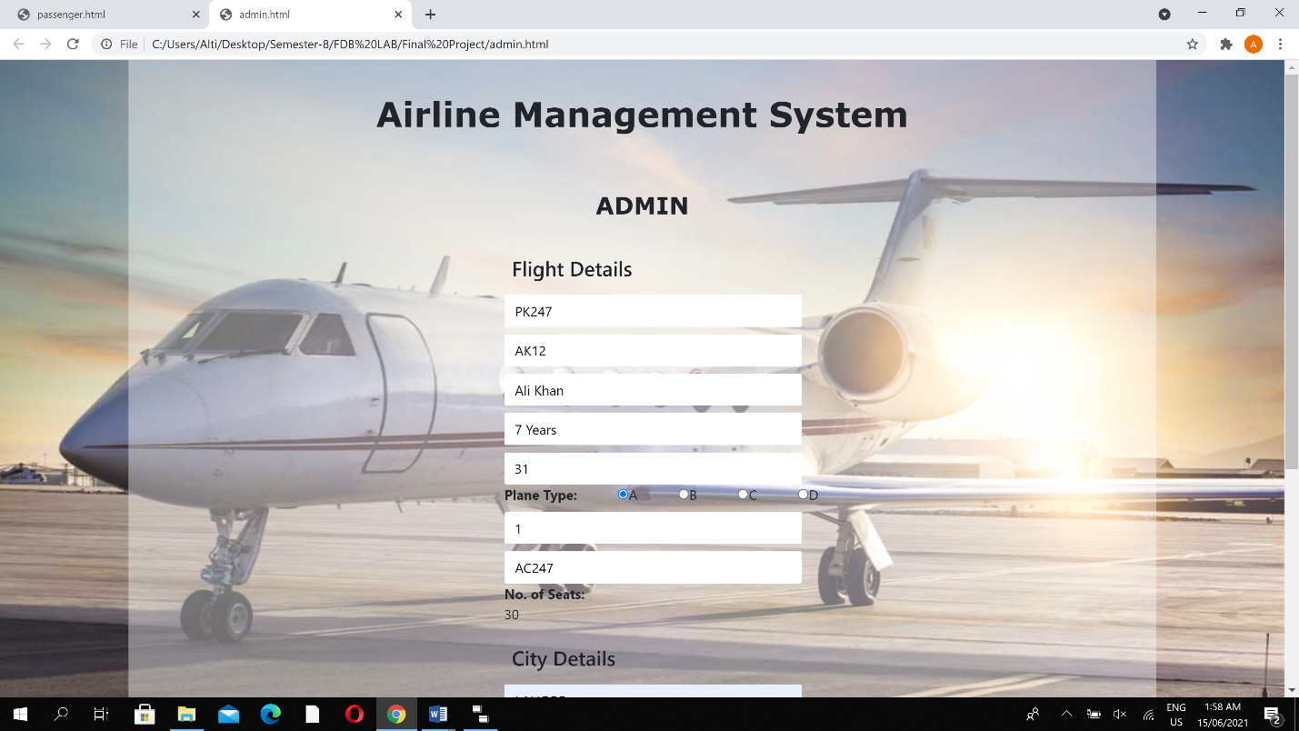

1. **WEBPAGE using xampp through php script.**

# SQL Data: (SLO 5.3)

use [Airline Management System]

create table Users

(

reg_no varchar(30) primary key

)

create table Passengers

(

Passenger_NO int primary key,

PassengerName varchar(30),

Address_P varchar(100),

GoldFlg int,

Magazine varchar(30),

SilverFlg int,

Seatingarrangement varchar(30)

)

create table Booking

(

BookingID int primary key,

Passno int,

classid int ,

Flightno int

)

alter table Booking add constraint bookingPassnoFK foreign key(Passno) references Passengers(Passenger_NO)

create table Class

(

Class_ID int primary key,

classType varchar(30),

seats_available int

)

alter table Booking add constraint bookingclassidFK foreign key(classid) references Class(Class_ID)

create table Administrator

(

Email_ID varchar(80) primary key ,

Password_A varchar(20),

flightno_A int

)

create table Flight

(

FlightNO int primary key,

pilotid varchar(30) ,

aircraft_id varchar(10) ,

meals_id int,

Arrival_time time,

Departure_time time,

)

alter table Booking add constraint bookingflightnoFK foreign key(Flightno) references Flight(FlightNO)

alter table Administrator add constraint adminflightnoFK foreign key(flightno_A) references Flight(FlightNO)

create table Pilot

(

Pilot_ID varchar(30) primary key,

Pilot_Name varchar(30),

Experience int,

Pilot_Age int,

planetypeNo varchar(30)

)

alter table Flight add constraint FlightpilottidFK foreign key(pilotid) references Pilot(Pilot_ID)

create table PlaneType

(

PlaneType_No varchar(30) primary key,

PlaneTypeName varchar(30)

)

alter table Pilot add constraint PilotplanetypetFK foreign key(planetypeNo) references PlaneType(PlaneType_No)

create table Aircraft

(

Aircraft_ID varchar(10) primary key,

no_of_seats int,

planetypeno varchar(30)

)

alter table Flight add constraint FlightaircraftidFK foreign key(aircraft_id) references Aircraft(Aircraft_ID)

alter table Aircraft add constraint ACplanetypetFK foreign key(planetypeNo) references PlaneType(PlaneType_No)----------

create table City

(

CityID int primary key,

Distance float,

CityName varchar(30),

TicketPrice float,

)

create table Meals

(

Meal_ID int primary key,

no_of_dishes int,

no_of_drinks int,

)

# alter table Flight add constraint FlightmealsidFK foreign key(meals_id) references Meals(Meal_ID) Tables:

# 

# Conclusion and Limitation (SLO 5.5)

# In the end we were successful in understanding and creating the Airline Management System. We used softwares like draw.io, Erwin, SQL data management system, xampp to accomplish our project. Through the draw.io software we were able to draw the EER diagram, then simulated relational schema through using ERWin software and made tables manually using word file. We were expecting that the table generated from the ERWin software had to be similar to the table created manually with respect to the foreign and primary keys. Fortunately, our analysis was correct both the tables had same attributes and relations. Afterwards we created SQL tables using sql management system. Finally, we were able to create the HTML webpage using css and javascript X The only issue we faced was using ASP.net for linking the database to the html webpage created. There were numerous errors while linking the front and back end. So we managed to use a template and alter it to our requirements and then finally connecting the template to our database using XAMPP software through php script. We were expecting the data input on our webpage to get inserted and displayed in our database. We weren’t able to add more details entries of the other attributes to our database due to shortage of time.

# References

# <https://app.diagrams.net/?src=about>

<https://www.youtube.com/watch?v=YNSnugnQYiI>

<https://www.youtube.com/watch?v=CDe5wfHAlAY>

Fundamentals of Database Systems (7th edition)

<https://www.w3schools.com/tags/att_style.asp>

<https://www.youtube.com/watch?v=q8OjCp_mpJA>

https://getbootstrap.com/